My Best Advice for Kids Who Love to Write

by Claire M. Caterer

If you’re like I was when I was a kid, you love to write stories. But maybe writing them is not quite enough for you. You want readers to read your work. I have to say, I’m no expert, but I have a few tips for you if you’d like to see your work in print online or on paper.

**Reading: You Gotta Do It—and Love It**

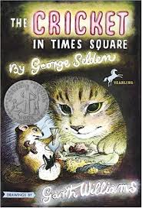 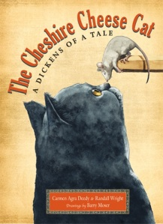 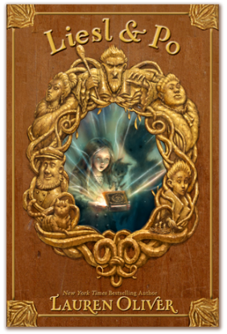 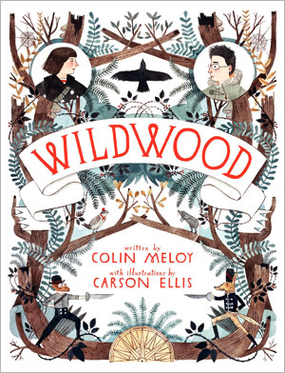

The best writing teachers are the ones we find in our favorite books. The more you read, the more you’ll learn about how stories work and what good writing sounds like in your head. Think about your favorite stories: What makes them good? Why do some stories move you more than other stories? How do your favorite writers make a scene exciting, sad, or scary? Then try those ideas in your own writing.

**Writing: You Gotta Do That, Too**



Try to write as often as you can. Your brain has a writing muscle just like your body has arm and leg muscles. The more you exercise your writing muscle, the better you’ll get.

**Once You Think You’re Done ...**

Put your story, poem, or play away for a while—at least a week or two. Then go back and read it. Pretend that someone else wrote it and ask yourself: How could this piece of writing be better? The key to good writing is good revision. It’s a drag, but we all have to do it. No one—NO ONE—writes a perfect story the first time out. Even very famous writers do a lot of REwriting. It’s how they got famous in the first place.

**Getting Your Work Published**

The best way to start is to start small. Try to get your shorter stories published first. If you’re successful, save printouts or hard copies of all your publications. When you’re ready to write that big novel, publishers will be impressed that you’ve already published shorter pieces.

There are lots of places to publish your work! Here are some resources to get you started:

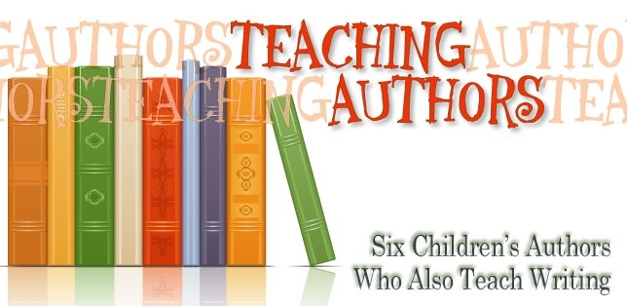

[The Teaching Authors website](http://www.teachingauthors.com/p/for-young-writers.html) has a long list of markets for young writers (a *market* is a place to publish your writing). Click on the link or visit www.TeachingAuthors.com.

[](http://www.newpages.com/writers-resources/young-authors-guide)

Need more markets? Check out the [Young Writers Guide](http://www.newpages.com/writers-resources/young-authors-guide) at www.NewPages.com for another list.

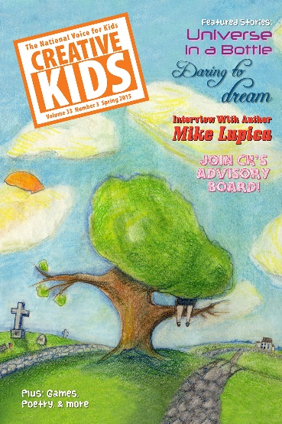

*Creative Kids* is a magazine written and illustrated entirely by kids ages 8–16*.* To find out how you can get published, click on [the submission guidelines here](http://www.ckmagazine.org/submissions/) (ckmagazine.org/submissions).

Be Really Patient, and Don’t Give Up!

No one wants to hear that success takes time. But sometimes it does. In fact, anyone who has any kind of artistic career—whether an actor, dancer, singer, painter, or writer—will tell you that she or he failed many times before succeeding. Other people’s opinions of your work are just that—opinions. If one publisher doesn’t accept your story, another one might. It doesn’t mean your writing isn’t good. Even published authors get rejection letters sometimes. What makes them *professional* is that they keep trying to make their work better.

I have a whole file folder full of rejection letters. But I also have a book published and another one on the way. You can do it too!

I’d Love to Hear From You!

C:\Program Files (x86)\Microsoft Office\MEDIA\CAGCAT10\j0195384.wmf

I wish you the best of luck with your writing. I’m afraid I can’t help you revise your stories (because I wouldn’t ever get my own writing done!). But I’d love to read any writing you do and answer any questions you have. Email me at [readerchat@cmcaterer.com](mailto:readerchat@cmcaterer.com).

Happy Writing!

Claire M. Caterer