On [date], author Claire M. Caterer will be coming to [school] for a special presentation about her fantasy novels and the writing process. Students are welcome to order the book(s) in advance. [TEACHER] will take book orders and the author will sign books personally on the day of the presentation.
We’re having an author visit!

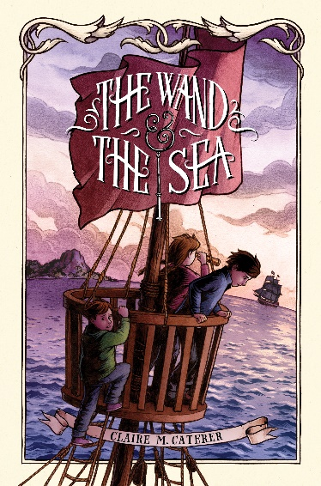
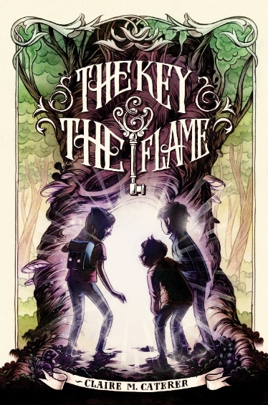
About the series:
Eleven-year-old Holly Shepard wants nothing more than to seek adventure outside of her humdrum American life. She gets her chance when her family travels to England and Holly receives an unusual gift: an iron key that unlocks the dangerous kingdom of Anglielle, where magic is outlawed and magical creatures are hunted. With her friend Everett and brother Ben, Holly battles to restore magic to Anglielle and defeat its ruthless rulers. But that means finding—and using—the magic within herself. A brand-new fantasy adventure series published by Simon & Schuster for ages 8 and up. Learn more at cmcaterer.com/books

“Filled with excitement, suspense, and adventure ... exciting from the very first page.” —Jack & Jill magazine

“With swordfights, spells, and an endearing cast of creatures, Holly’s journey makes for a rousing adventure.”
—Library Media Connection

Chosen by the ABC Children’s Group of the ABA as a New Voices pick
Featured in the Children’s Book Council Winter Seasonal Showcase
Featured as one of 2013’s Best Books for Children & Teens on Kansas City’s KCUR-FM

If you would like to own a signed copy of either book, fill out the form below
and return it to [TEACHER] by [DATE]. Please make checks out to [store].

STUDENT NAME ____________________________________________

TEACHER’S NAME___________________________________________ GRADE # _______

___COPIES OF THE KEY & THE FLAME X [price] = $___________ +
___ COPIES OF THE WAND & THE SEA X [price] = $___________ = TOTAL: $ __________

